Omar Mahmud

Professor Labouseur

Lab 1

01/28/15

1. As a student worker at our lovely Marist College Help Desk, I use our database everyday in order to verify student , faculty, staff, affiliate, vendor and guest records. There are many pieces of data used in our database, which is called LDAP. Some data would include a person’s full name, surname, birthday, CWID, email address, password status, affiliation with the college, job code, last date a password has been changed, last time he/she worked at Marist and User ID. However, if the database was not organized, then these pieces of data are essentially meaningless. In our system, we give this data structure by assigning these data sets into profiles and allow us to determine if the person has an active Marist account, valid CWID, attends Marist, works at Marist, is a current student, has an invalid password, is a faculty administrator, etc. ; moreover, it allows us to determine if the profile of a student, guest, faculty member, staff member, affiliate of the college, alumni, prospective student or a vendor at the school. I can show how this data is meaningless because all of these profiles have a “1”, “0”, or “-1” assigned to them. If this data wasn’t structured, then we would just see a bunch of 1s, 0s, and -1s. However, when structured into records, we will realize that these numbers represents a status of a Marist account password as valid, invalid, or expired. This helps make my job a lot easier when I have to reset passwords, or when I get phone calls from angry people who cannot login into their account.
2. 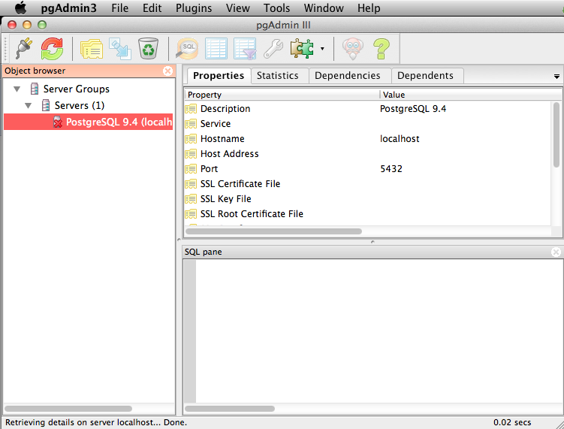There are hierarchical and network data models that existed before the relational models. The hierarchical model was a tree-oriented model and only operated at the physical level which made it really difficult for programmers to write code efficiently. The network model was graph-oriented and was also at the physical level. Some of its disadvantages included a lack structural independence because it was difficult to make any modifications to the database and it only allows for data to accessed one record at a time. I think XML isn’t a bad alternative to relational data tables because the XML is not OS-specific and might be easier to use for object-oriented language programmers, as it closely resembles it.

**Screenshot of PGAdmin on my Mac**